Advanced Programming Language

Assignment 7

Chinmay Dorge

LCS2020022

Q1)” Synchronization in Java is the capability to control the access of multiple threads to any

shared resource.” Write a java program demonstrating thread synchronization using

1)Synchronization method

2)Synchronization block

Code: Q1.java

public class Q1 {  
 Integer i = 0;  
 synchronized int count1() {  
 i++;  
 return i;  
 }  
  
 int count2 () {  
 synchronized (i) {  
 i += 2;  
 }  
 return i;  
 }  
  
 public static void main(String[] args) {  
 var obj = new Q1();  
 Runnable r1 = new Runnable() {  
 public void run(){  
 System.out.println(obj.count1());  
 }  
 };  
 Runnable r2 = new Runnable() {  
 public void run(){  
 System.out.println(obj.count2());  
 }  
 };  
 Thread a = new Thread(r1);  
 Thread b = new Thread(r1);  
 Thread c = new Thread(r2);  
  
 try {  
 a.start();  
 Thread.sleep(20);  
 b.start();  
 Thread.sleep(20);  
 c.start();  
 Thread.sleep(20);  
 a.join();  
 b.join();  
 c.join();  
 } catch (InterruptedException e) {  
 e.printStackTrace();  
 }  
 }  
}

Output:

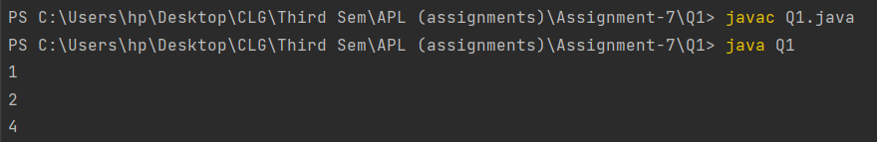

Q2) Write a java program to demonstrate the use of static synchronized method. Create 3 threads say t1, t2 and t3 respectively and make use of static synchronization.

Code: Q2.java

class printNum  
{  
 public static synchronized void func(int n,int m) {  
 for(int i=n;i<=m;i++){  
 System.out.print(i + " ");  
 try {  
 Thread.sleep(500);  
 }  
 catch(Exception e){  
 System.out.println(e);  
 }  
 }  
 System.out.println();  
 }  
}  
class t1 extends Thread {  
 @Override  
 public void run() {  
 printNum.func(1,10);  
 }  
}  
class t3 extends Thread {  
 @Override  
 public void run() {  
 printNum.func(21,30);  
 }  
}  
class t2 extends Thread {  
 @Override  
 public void run() {  
 printNum.func(11,20);  
 }  
}  
public class Q2 {  
 public static void main(String[] args) {  
 t1 t1 = new t1();  
 t2 t2 = new t2();  
 t3 t3 = new t3();  
 t1.start();  
 t2.start();  
 t3.start();  
 }  
}

Output:

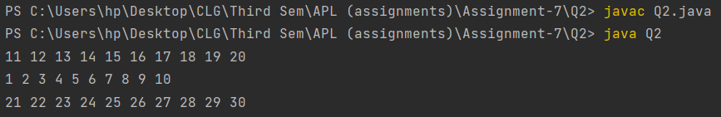

Q3)” Deadlock in Java is a part of multithreading. Deadlock can occur in a situation when a thread is waiting for an object lock, that is acquired by another thread and second thread is waiting for an object lock that is acquired by first thread. “Implement a java program that goes into deadlock by creating 4 threads t1, t2, t3 and t4. You should make use put print statements at appropriate positions to make it evident that your

program has entered deadlock.

Code: Q3.java

public class Q3{  
 static Object Lock_1 = new Object(), Lock_2 = new Object();  
 public static void main(String[] args) {  
 Thread t1 = new Thread(new Runnable() {  
 public void run(){  
 try{  
 System.out.println("t1 locking Lock_1.");  
 synchronized(Lock_1){  
 System.out.println("t1 has locked Lock_1");  
 Thread.sleep(1000);  
 System.out.println("t1 trying to lock Lock_2");  
 synchronized(Lock_2){  
 System.out.println("t1 has acquired both Lock_1 and Lock_2 (We will never reach here)");  
 }  
 }  
 }catch(InterruptedException e){  
 e.printStackTrace();  
 }  
 }  
 });  
 Thread t2 = new Thread(new Runnable() {  
 public void run(){  
 try{  
 System.out.println("t2 locking Lock_2.");  
 synchronized(Lock_2){  
 System.out.println("t2 has locked Lock_2");  
 Thread.sleep(1000);  
 System.out.println("t2 trying to lock Lock_1");  
 synchronized(Lock_1){  
 System.out.println("t1 has acquired both Lock_1 and Lock_2");  
 }  
 }  
 }catch(InterruptedException e){  
 e.printStackTrace();  
 }  
 }  
 });  
 Thread t3 = new Thread(new Runnable() {  
 public void run(){  
 try{  
 System.out.println("t3 trying to lock Lock_1");  
 Thread.sleep(1000);  
 synchronized(Lock_1){  
 System.out.println("t3 has locked Lock_1 (We will never reach here)");  
 }  
 }catch(InterruptedException e){  
 e.printStackTrace();  
 }  
 }  
 });  
 Thread t4 = new Thread(new Runnable() {  
 public void run(){  
 try{  
 System.out.println("t4 trying to lock Lock_2.");  
 Thread.sleep(1000);  
 synchronized(Lock_2){  
 System.out.println("t4 has locked Lock_2 (We will never reach here)");  
 }  
 }catch(InterruptedException e){  
 e.printStackTrace();  
 }  
 }  
 });  
  
 t1.start();  
 t2.start();  
 t3.start();  
 t4.start();  
  
 try{  
 Thread.sleep(2000);  
 if(t1.isAlive()) {  
 System.out.println("t1 is in deadlock.");  
 }  
 if(t2.isAlive()) {  
 System.out.println("t2 is in deadlock.");  
 }  
 if(t3.isAlive()) {  
 System.out.println("t3 is in deadlock.");  
 }  
 if(t4.isAlive()) {  
 System.out.println("t4 is in deadlock.");  
 }  
 } catch(InterruptedException e){  
 e.printStackTrace();  
 }  
 }  
}

Output:

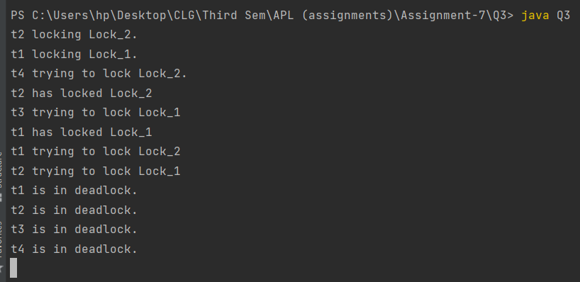

Q4) Inter-thread communication or Co-operation is all about allowing synchronized threads to communicate with each other.

Write a java program using three threads t1, t2 and t3 using Thread classes in separate files. Make use of them in your main class. Using the demonstrate the working of

1)wait()

2)notify()

3)notifyAll()

Code: FirstThread.java

package Threads;  
public class FirstThread extends Thread {  
 public Object obj;  
 public FirstThread(Object obj){  
 this.obj = obj;  
 }  
 public void run(){  
 synchronized (obj){  
 System.out.println("Executing FirstThread");  
 System.out.println("FirstThread will wait for SecondThread");  
 try {  
 obj.wait();  
 }catch(InterruptedException e){  
 e.printStackTrace();  
 }  
 System.out.println("FirstThread completed");  
 obj.notifyAll();  
 }  
  
 }  
}

SecondThread.java

package Threads;  
public class SecondThread extends Thread {  
 public Object obj;  
 public SecondThread(Object obj){  
 this.obj = obj;  
 }  
 public void run(){  
 synchronized (obj){  
 System.out.println("Executing Second Thread");  
 System.out.println("SecondThread will wait for ThirdThread");  
 try{  
 obj.wait();  
 }catch(InterruptedException e){  
 e.printStackTrace();  
 }  
 System.out.println("SecondThread completed");  
 obj.notify();  
 }  
 }  
}

ThirdThread.java

package Threads;  
public class ThirdThread extends Thread{  
 public Object obj;  
 public ThirdThread(Object obj){  
 this.obj = obj;  
 }  
 public void run(){  
 synchronized (obj){  
 System.out.println("Executing Third Thread");  
 obj.notify();  
 System.out.println("ThirdThread completed");  
 }  
 }  
}

Q4.java

import Threads.FirstThread;  
import Threads.SecondThread;  
import Threads.ThirdThread;  
public class Q4 {  
 public static void main(String[] args) {  
 Object obj = new Object();  
 FirstThread thread1 = new FirstThread(obj);  
 SecondThread thread2 = new SecondThread(obj);  
 ThirdThread thread3 = new ThirdThread(obj);  
  
 thread1.start();  
 thread2.start();  
 thread3.start();  
  
 try {  
 thread3.join();  
 Thread.sleep(100);  
 thread1.interrupt();  
 thread2.interrupt();  
 } catch (InterruptedException e) {  
 e.printStackTrace();  
 }  
 }  
}

Output:

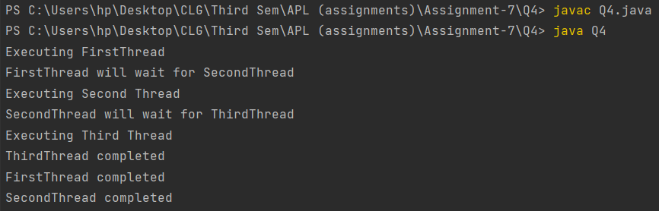

Q5) The 3 methods provided by the Thread class for interrupting a thread

• public void interrupt()

• public static Boolean interrupted()

• public Boolean isInterrupted()

Write a java program that demonstrates the use of above three methods. Create four threads t1, t2, t3 and t4 and demonstrate. Also, handle the exception, when interrupt is called when threads when sleep() or wait() are already called on them.

Code: Q5.java

public class Q5 {  
 public static void main(String[] args) {  
 Thread t1 = new Thread(() -> {  
 try {  
 Thread.sleep(1000000);  
 } catch (InterruptedException e) {  
 System.out.println("interrupted first thread");  
 }  
 });  
 Thread t2 = new Thread(new Runnable() {  
 @Override  
 public void run() {  
 try {  
 synchronized (this) {  
 this.wait();  
 }  
 } catch (InterruptedException e) {  
 System.out.println("interrupted second thread");  
 }  
 }  
 });  
 Thread t3 = new Thread(() -> {  
 try {  
 Thread.sleep(100000);  
 } catch (InterruptedException e) {  
 System.out.println("interrupted returned " + Thread.interrupted());  
 }  
 });  
 Thread t4 = new Thread(new Runnable() {  
 @Override  
 public void run() {  
 try {  
 synchronized (this) {  
 this.wait();  
 }  
 } catch (InterruptedException e) {  
 System.out.println("interrupted returned " + Thread.interrupted());  
 }  
 }  
 });  
  
 t1.start();  
 t2.start();  
 t3.start();  
 t4.start();  
  
 System.out.println("interrupting first thread:");  
 t1.interrupt();  
 System.out.println("t1.isInterrupted() = " + t1.isInterrupted());  
 System.out.println();  
 System.out.println("interrupting second thread:");  
 t2.interrupt();  
 System.out.println("t2.isInterrupted() = " + t2.isInterrupted());  
 System.out.println();  
 System.out.println("interrupting third thread:");  
 t3.interrupt();  
 System.out.println("t3.isInterrupted() = " + t3.isInterrupted());  
 System.out.println();  
 System.out.println("interrupting fourth thread:");  
 t4.interrupt();  
 System.out.println("t4.isInterrupted() = " + t4.isInterrupted());  
  
 }  
}

Output:

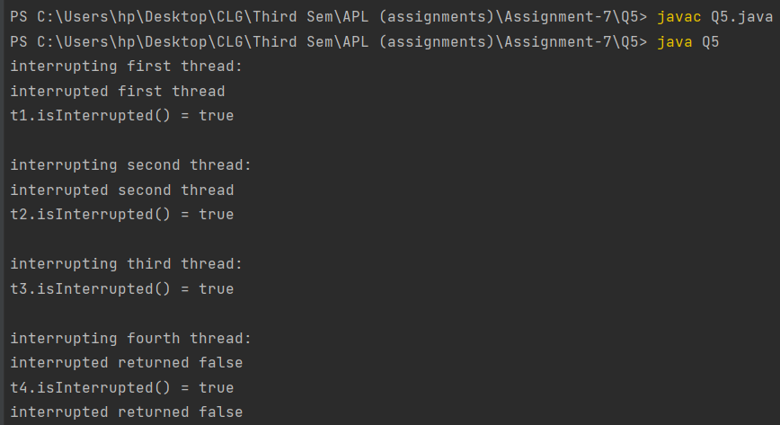

Note: The code has been sent with the zip file and is also

available on GitHub. Repo link

https://github.com/Chinmay-Dorge/Advanced-Programming-Assignments